Variable Setup
On azure home page type invoices in the search bar at the top.
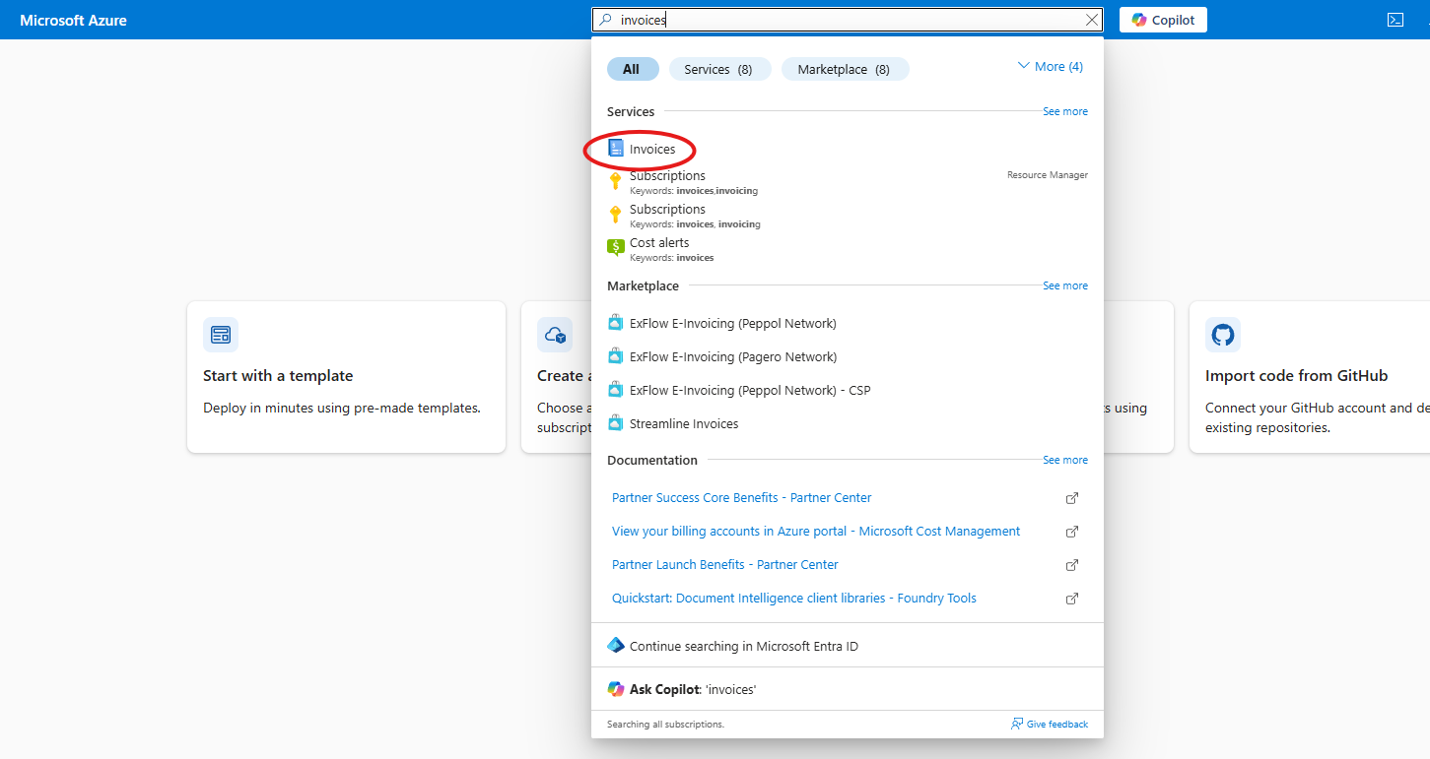
Click on invoices.
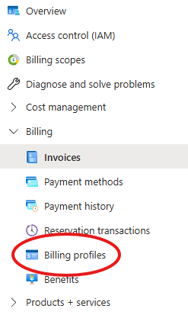
Click on find billing profiles under the billing section of the left hand side menu.
Select your profile as it should be the only one that pops up.
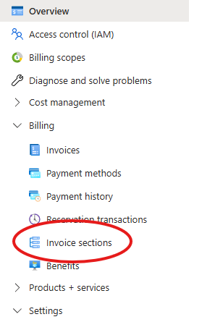
Select invoice sections.
Then select your profile.
Inside invoice section you will need to do 2 things.
- Set up contributor role in Access control (IAM)
- Finding the variables for variable.tf

Set up contributor role in Access control (IAM)
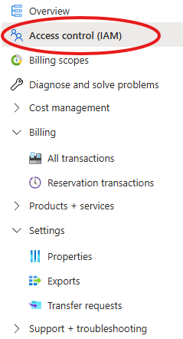
Within the invoice section select Access control (IAM).
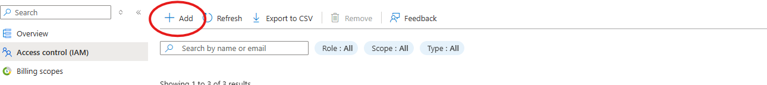
Click the add button as shown above.
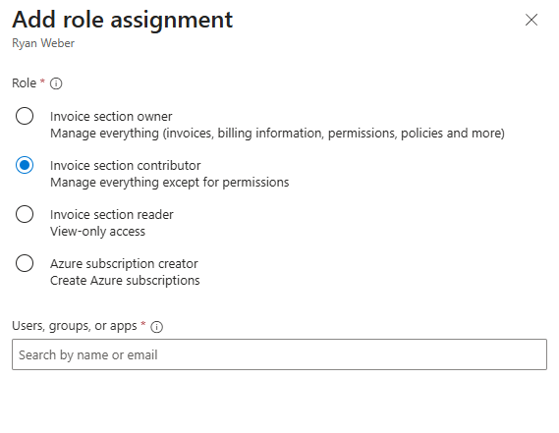
On the side a role menu should pop up. Select invoice section contributor. Make sure to assign it to your user email you are logged in with.
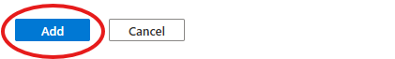
Then click “add” to add the role.
Now you can move on to the second step.

Finding the variables for variable.tf
While still in the invoice section look to the left side drop down menu and under setting you should see the properties tab.
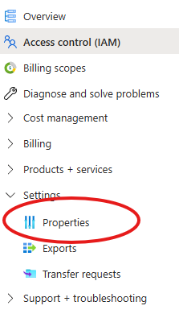
Click on properties.
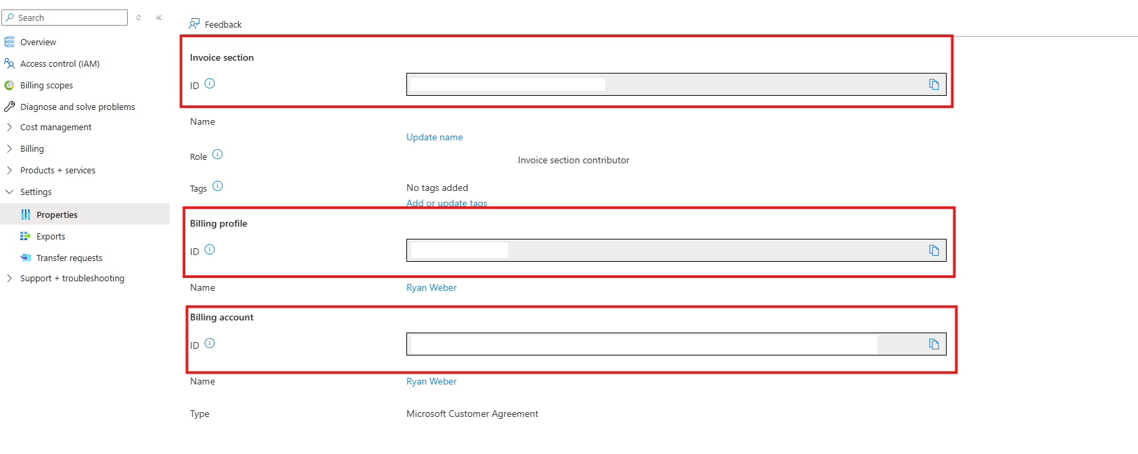
In properties you should see the variables for invoice section, billing profile and billing account.
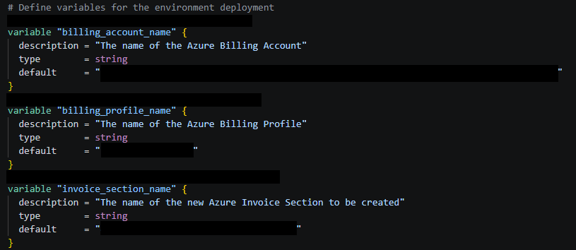
Copy and paste these variables into variables.tf on the default section inside of the c01subscription folder.
Make sure to user quotation marks at the beginning and end of the variable.
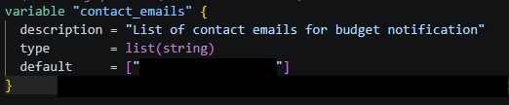
After this scroll down in varables.tf and look for contact emails. Add your contact email in the default section as a list with quotation marks at the start and end as shown above.
After this you should now be ready to run c01.

